T E N T E R D E N K E N T

**Parish Priest:** Fr Behruz Rafat **Telephone** 01580 762785 Mobile: 07903 986646

**Address:** The Presbytery, 47 Ashford Road, Tenterden, Kent TN30 6LL.

**Parish E-mail** [behruzrafat@rcaos.org.uk](mailto:behruzrafat@rcaos.org.uk) **Parish Website:** www.standrewstenterden.org

**Deacon:** Rev. Jolyon Vickers **Telephone:** 01580 766449 **Email:** jolyonvickers@rcaos.org.uk **Hire of Parish Hall:** Lesley McCarthy 07791 949652 **E-mail:** [bookings.standrews@talktalk.net](mailto:bookings.standrews@talktalk.net)

**Newsletter Editor:** Patricia Sargent 01233 850963 **E-mail:** sargentpat51@gmail.com

**Newsletter for the week commencing 9th August 2020**

**Nineteenth Sunday in Ordinary Time**

**Entrance Antiphon: Look to your covenant, O Lord, and forget not the life of your poor ones for ever. Arise, O God, and defend your cause, and forget not the cries of those who seek you.**

**First Reading: 1 Kings 19:9, 11-13**

**Psalm 84 Response: Let us see, O Lord, your mercy and give us your saving help.**

**Second Reading: St Paul to the Romans 9: 1-5**

**Gospel: Matthew 14: 22-33**

**Acclamation Lk19: 38: Alleluia, alleluia! Blessings on the King who comes, in the name of the Lord! Peace in heaven and glory in the highest heavens! Alleluia**

**Father Behr writes:**

Dear parishioners

Next weekend we celebrate the Solemnity of the Assumption.  We have been given Mary as our loving mother.  This is not sentimentality, but a gift Jesus gave from the Cross to every Christian.  As Jesus was dying, looking tenderly at his mother Mary, he said to her ‘Behold your son’ then he said to the disciple he loved, representing every Christian, ‘Behold your mother’ and from that day Mary became the mother of all Christians. (John 19) We should not let a single day go by without asking her for her prayers and her powerful help.  She wants each and every one of her children to attain the happiness of Heaven. She does not want anyone to be lost.  The prayer of the holy Rosary is particularly powerful.

*The Most Holy Virgin in these last times in which we live has given a new efficacy to the recitation of the Rosary to such an extent that there is no problem, no matter how difficult it is, whether temporal or above all spiritual, in the personal life of each one of us, of our families… that cannot be solved by the Rosary. There is no problem, I tell you, no matter how difficult it is, that we cannot resolve by the prayer of the Holy Rosary.* Sister Lucia

**Confession**

I am available for Confession by appointment and although we are not able to use the confessional box, we can still create a space in our parish church which respects the confidentiality of confession

**Your Prayers are asked for:**

**Those recently deceased**: Michael McDermott RIP - funeral date to be advised. Gregory Munton RIP, retired Ophthalmic Surgeon at Kent Ophthalmic Hospital and father of parishioner Rachel Tidd. His funeral will be held at Vinter's Park on Saturday 15th August.

**Those ill or infirm:** Jennifer Jorden, Joe Adams, Ellie Lawrence, Anne Bryant, Eric Booth, Patricia Hook, Elena Peck (senior), Marjorie Dumbleton, Josie Payne, Joe Venables, Linda Wolff and all those self-isolating or suffering from COVID-19

**Those whose anniversaries of death occur at this time:** Ronald Carey, David Collard, Eva Ford, Evelyn Robertson, Joseph Puxty, Catherine Lista, Alex Holmes, Philomena Curtin and Ann Finn

**This week**

A couple of requests…

"Have you any plastic flowerpots that you wish to give away?" A local charity would be most grateful - the larger the better. Please leave at the church for Jolyon's attention. The charity helps people through horticulture. Their website is Hands of Hope in Hawkhurst.

"Any folk willing to help with the small altar linen laundering?" Approximately 6 purificators, 6 lavabo towels, 1 or 2 corporals a week. Please see Jolyon.

**This week’s services until social distancing is relaxed:**

|  |  |  |  |
| --- | --- | --- | --- |
| **Mass will be held daily at 10am except on Wednesday when there will be a Service of the Word and Holy Communion at 10am** | | | |
| **Feasts during the week** | | | |
| Sunday 9th August | 19th Sunday of the year | Thursday 13th August | Saints Pontian, Pope and Hippolytus |
| Monday 10th August | St Lawrence, Deacon & Martyr | Friday 14th August | St Maximillian Mary Kolbe |
| Tuesday 11th August | St Clare | Saturday 15th August | Feria |
| Wednesday 12th August | St Jane Frances de Chantal | Sunday 16th August | THE ASSUMPTION OF THE BLESSED VIRGIN MARY |

**Future events**

Dear Friends,

Following Fr Behr's announcement at Mass on Sunday 2/8/2020, this is our revised procedure regarding places for Mass.

With the Parish Centre and the Church now available for our daily Mass at 10am (or Word and Communion on a Wednesday), we have increased seating capacity.

In order to reduce the administration involved and to introduce some spontaneity into going to Church, we have decided to relax the requirements to book a place, **other than on Sundays**. So, for daily services (other than Sundays), please just turn up and take up a seat. You are very welcome. Please remember the social distancing requirements, and complete a Track and trace form and leave it in the container in the church.

Because there is a need to seat larger numbers of people **on Sundays**, please still book with Jolyon on [jolyonvickers@rcaos.org.uk](mailto:jolyonvickers@rcaos.org.uk) or 01580 766449.

For Sundays, we will be moving to a “standing order” situation with a permanent booking for particular seat/seats. It will then only be necessary to notify Jolyon, when you will not be using your designated seat/seats, so they can be allocated to someone else.

It is absolutely essential you complete and bring with you a Track and Trace form, so we are able to identify who has attended at every service, just in case we experience a COVID outbreak situation.

**Please note you are now required to wear a face mask whilst on the premises**.

**Please can we also remind you:**

**No stewards = No Services**

**No cleaners= No Services**

**Please offer to help if you can**

**Father John’s Farewell Gift**

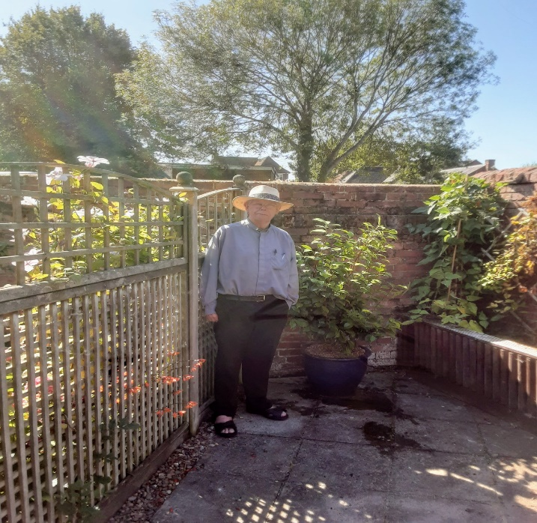

Please see above our gift to Father John.

At his request, it is a mature Camelia with Pink and White flowers

This has been planted up in a frost proof glazed pot.

If you would like to contribute to this gift,

please put your contribution in an envelope marked “Fr John gift”, along with a message, (which will be affixed to a card) and hand it to Father Behr or Deacon Jolyon.

Once the cost of the plant etc has been recovered, the balance will be spent on improvements to the safety and look of his courtyard garden, which will start next week.